How to use the SFTP Service!

1. Download FileZilla to your device. <https://filezilla-project.org/download.php?type=client>
2. Get the credentials for the SFTP login:
   1. Protocol = SFTP – SHH File Transfer Protocol
   2. Host = gss1.natwest.com OR gss2.natwest.com
   3. User = Y01AQLCL (2nd character is zero)
   4. Key file = id_rsa (link it!)
3. 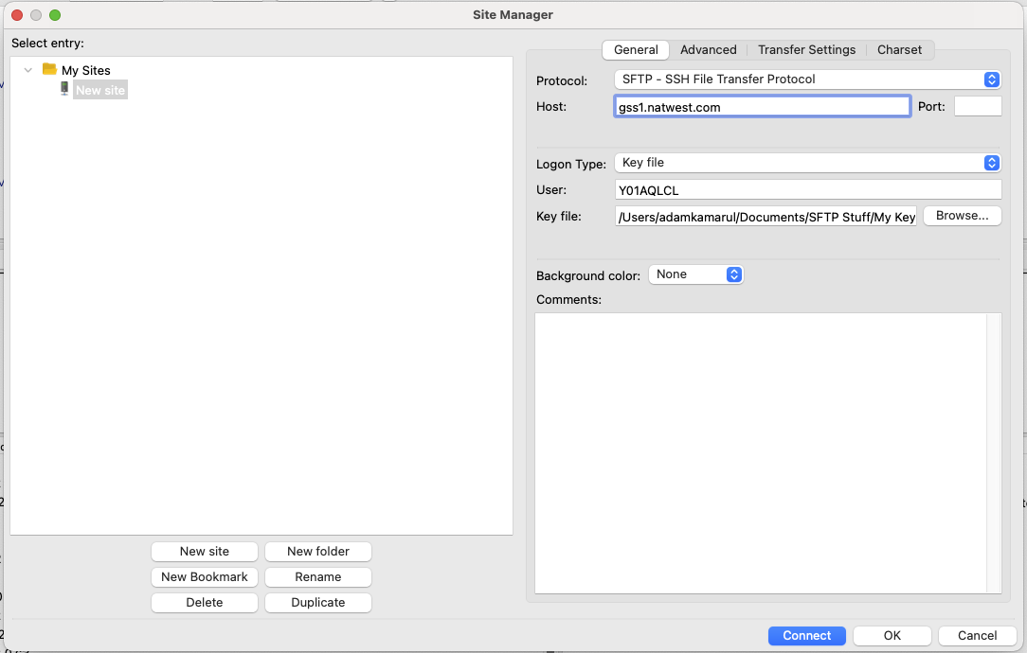Open up Site Manager in FileZilla, input the following credentials (as shown below) and connect!
4. A pop up should appear after connecting:

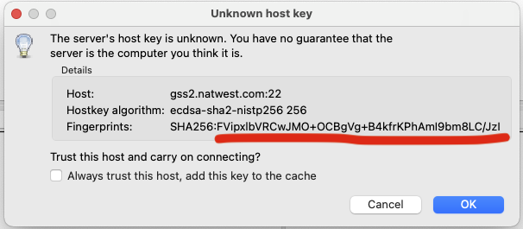

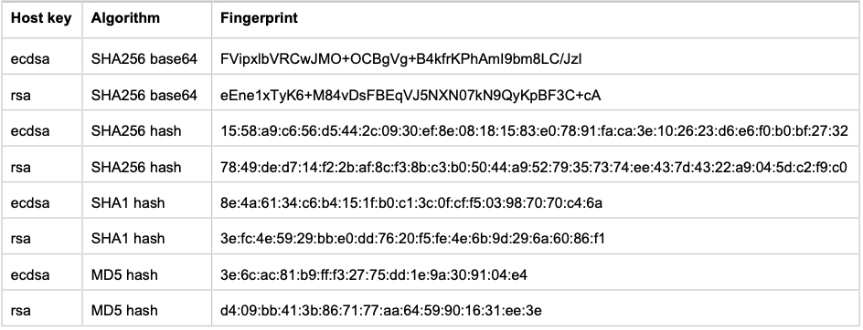Check the Fingerprint (the block of text that in underlined in red) and make sure it matches with one of the Host Keys!

1. 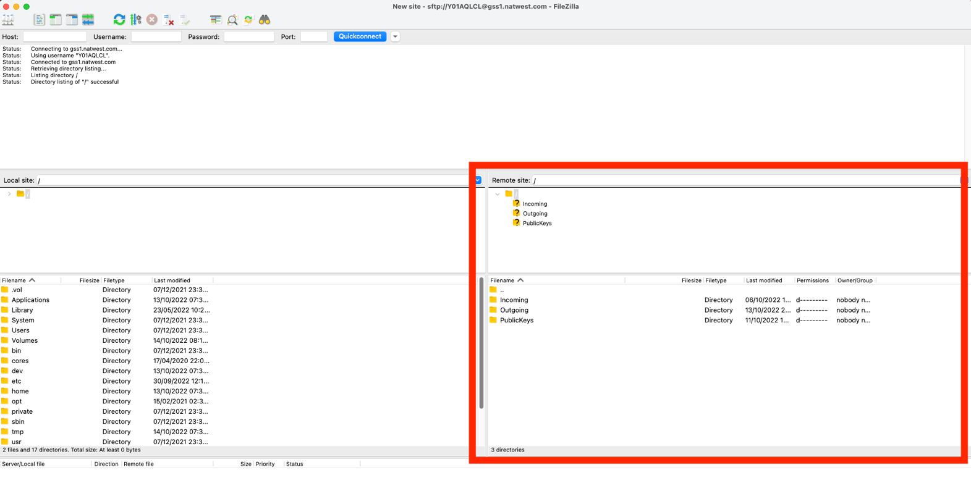Should be connected to the Bankline file server!
2. The file that are needed should be in the Outgoing folder in their file server. Once a file has been downloaded, it will be moved to the Archive folder which in in the Outgoing folder!
3. 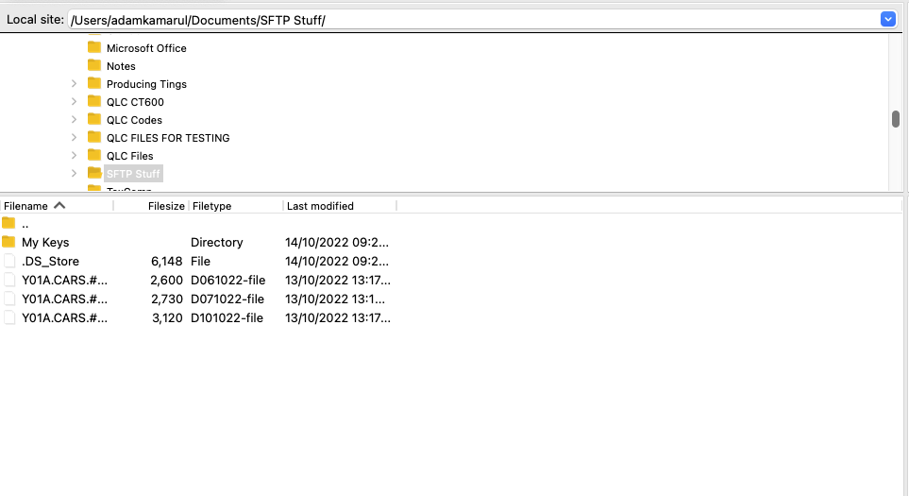Make sure you select where you want these downloaded files to appear, in the image below, in my SFTP Stuff folder!
4. Use the Web App <https://bank-qlc.herokuapp.com/> to scrape the transactions from HMRC!